4.4 Screen Shots
Index.html: This form can entering into the main portal and access and search various brands and registrations yourself


Registration.html: This form takes the details such as fname, lname gender, email dob, contact number, city they provide and inserts the record into the database.

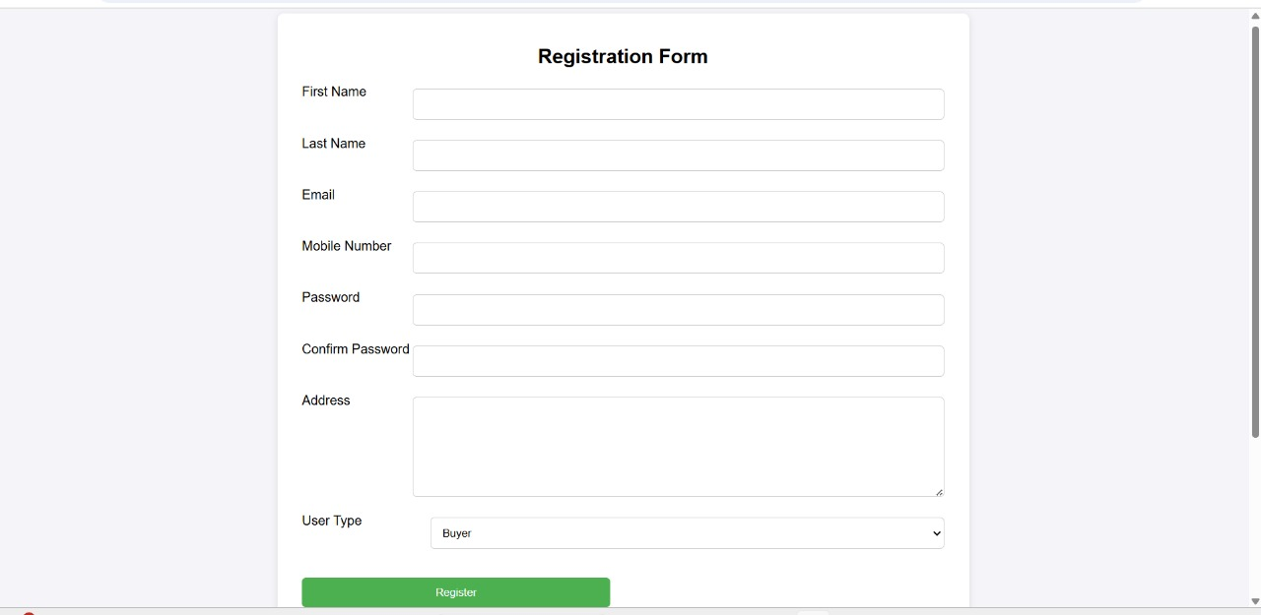

Contact.html: This form can displays the contact details and management details
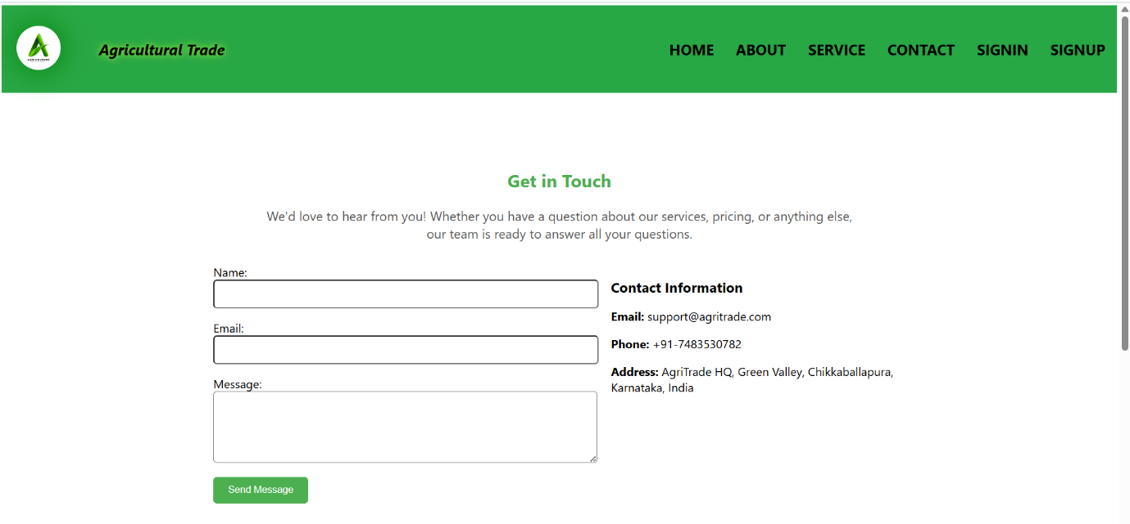

Message.html: Based on the image you provided, the message page seems to be a dashboard-style layout showing
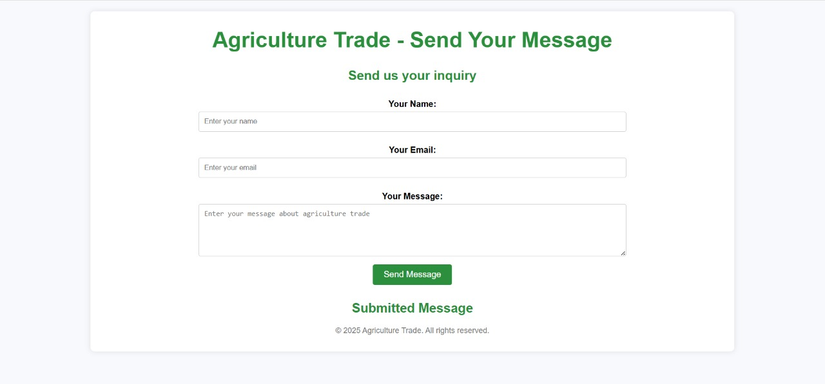

login.html: Approves new user/traders registrations by checking if the user exists and assigns them a unique ID.
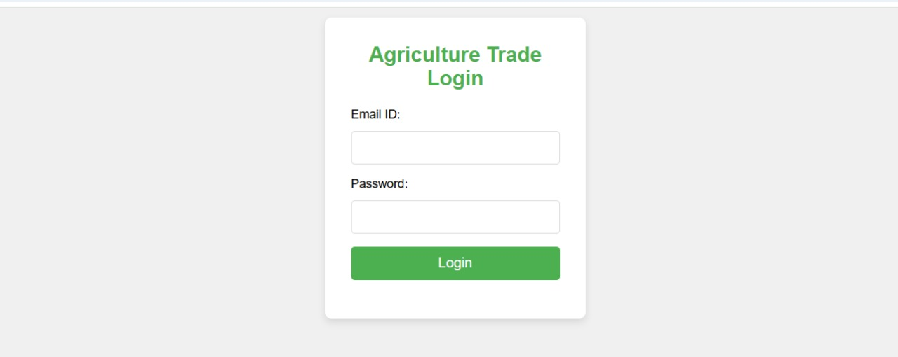Blog.html: The agri trade platform is a digital solution that simplifies the process of buying and selling agricultural products.
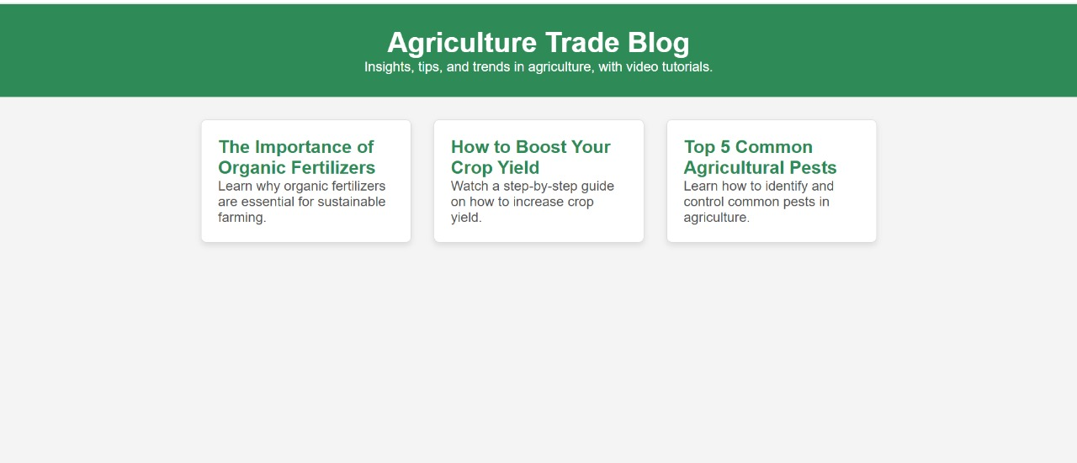

Our_services.html: This section provides a detailed overview of all the services offered by the agri trade platform. 
Products.html: This form displays all the various brands and latest offers such as images etc Trusted Agri Trade Products Shop We provide a wide range of high – quality agricultural products to meet the needs of users ,gardeners, and agri-businesses. 